Online appendix (not for publication)

Figure A1: Location of sample villages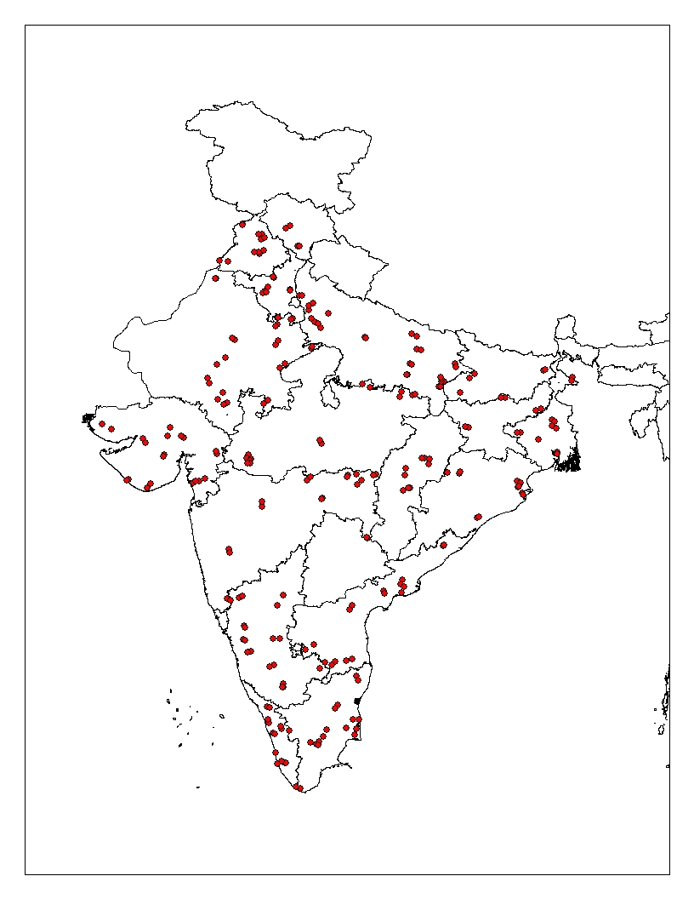

A1: Timing for panchayat elections, NREGS roll-out and data collection
 | 2005 | 2006 | 2007 | 2008 | 2009 | 2010 | 2011 | 2012 | 2013 | 2014 | 2015
Andhra Pradesh |  | $$√$$ |  |  |  |  | $$√$$
Bihar |  | $$√$$ |  |  |  |  | $$√$$
Chhattisgarh | $$√$$ |  |  |  |  | $$√$$
Haryana | $$√$$ |  |  |  |  | $$√$$ |  |  |  |  | $$√$$
Maharashtra | $$√$$ |  |  |  |  | $$√$$ |  |  |  |  | $$√$$
Madhya Pradesh | $$√$$ |  |  |  |  | $$√$$ |  |  |  |  | $$√$$
Orissa |  |  | $$√$$ |  |  |  |  | $$√$$ |  |  | $$√$$
Rajasthan | $$√$$ |  |  |  |  | $$√$$
Tamil Nadu |  | $$√$$ |  |  |  |  | $$√$$ |  |  |  | $$√$$
Uttar Pradesh | $$√$$ |  |  |  |  | $$√$$
West Bengal |  |  |  | $$√$$ |  |  |  |  | $$√$$ |  | $$√$$
Note: Lightly shaded areas indicate the period of roll-out of NREGS. Phase 1 of the program was rolled out in Feb 2006 in 200 districts, phase 2 of the program was rolled out in April 2007 in next 130 districts and Phase 3 of the program was rolled out in April 2008 in remaining districts of India. The darker shading in 2014 indicates the time of data collection for the survey used in the analysis. $√$ indicates the timing of panchayat election in states of India.

Table A2: pradhan characteristics by reservation status
 | Total |  | Ever reserved |  | Never reserved |  | p-value
 | Mean | SD | Mean | SD | Mean | SD
Pradhan characteristics
Previously contested position | 0.147 | 0.355 | 0.133 | 0.341 | 0.162 | 0.371 | 0.592
Held gov’t position before | 0.429 | 0.497 | 0.422 | 0.497 | 0.438 | 0.499 | 0.840
Up to primary school | 0.27 | 0.445 | 0.361 | 0.483 | 0.175 | 0.382 | 0.007
Up to High School | 0.264 | 0.442 | 0.253 | 0.437 | 0.275 | 0.449 | 0.752
Higher secondary and above | 0.344 | 0.476 | 0.265 | 0.444 | 0.425 | 0.497 | 0.032
Higher educ. & professional | 0.123 | 0.329 | 0.12 | 0.328 | 0.125 | 0.333 | 0.930
SC | 0.601 | 0.491 | 0.639 | 0.483 | 0.563 | 0.499 | 0.325
ST | 0.074 | 0.262 | 0.084 | 0.28 | 0.063 | 0.244 | 0.596
OBC | 0.110 | 0.314 | 0.108 | 0.313 | 0.112 | 0.318 | 0.935
OC | 0.209 | 0.408 | 0.169 | 0.377 | 0.25 | 0.436 | 0.204
Hindu | 0.509 | 0.501 | 0.41 | 0.495 | 0.613 | 0.490 | 0.009
Muslim | 0.092 | 0.290 | 0.096 | 0.297 | 0.087 | 0.284 | 0.846
Other | 0.398 | 0.491 | 0.493 | 0.503 | 0.300 | 0.461 | 0.011
No of observations | 163 |  | 83 |  | 80
Note: Own’s calculation from survey data

Table A3: Household and individual’s characteristics by reservation status
 | Total |  | Ever reserved |  | Never reserved |  | p-value
 | Mean | SD | Mean | SD | Mean | SD
Panel A: Household characteristics
Female household head | 0.117 | 0.322 | 0.114 | 0.318 | 0.120 | 0.325 | 0.172
Head's age | 49.433 | 12.785 | 49.382 | 12.881 | 49.484 | 12.689 | 0.581
Head's education (years) | 3.840 | 4.140 | 3.798 | 4.114 | 3.881 | 4.165 | 0.165
Married head (%) | 0.844 | 0.363 | 0.840 | 0.367 | 0.848 | 0.359 | 0.136
Unmarried head | 0.015 | 0.120 | 0.014 | 0.117 | 0.015 | 0.123 | 0.416
Widowed /separated head | 0.140 | 0.347 | 0.144 | 0.351 | 0.135 | 0.342 | 0.069
Household size | 4.620 | 2.309 | 4.653 | 2.378 | 4.587 | 2.239 | 0.049
No. of males 15-65 years | 1.684 | 1.065 | 1.693 | 1.091 | 1.676 | 1.039 | 0.253
No. of females 15-65 years | 1.601 | 0.911 | 1.609 | 0.931 | 1.593 | 0.891 | 0.224
No. of youth <15 years | 1.142 | 1.382 | 1.160 | 1.400 | 1.124 | 1.363 | 0.069
No. of fem. youth (< 15 a) | 0.554 | 0.902 | 0.561 | 0.914 | 0.546 | 0.890 | 0.267
Max. education level | 14.427 | 3.261 | 14.451 | 3.287 | 14.404 | 3.236 | 0.312
Average age of members | 32.805 | 13.435 | 32.953 | 13.747 | 32.657 | 13.116 | 0.128
Hindu | 0.915 | 0.279 | 0.915 | 0.278 | 0.914 | 0.280 | 0.739
SC/ST | 0.407 | 0.491 | 0.405 | 0.491 | 0.408 | 0.491 | 0.702
No. of obs. | 17,948 |  | 9,534 |  | 8,414
Panel B: Individual characteristics
Share of female | 0.491 | 0.500 | 0.492 | 0.500 | 0.491 | 0.500 | 0.705
Age | 39.913 | 15.729 | 39.896 | 15.743 | 39.929 | 15.715 | 0.799
No education but literate | 0.396 | 0.489 | 0.394 | 0.489 | 0.398 | 0.489 | 0.321
Up to primary | 0.198 | 0.398 | 0.197 | 0.398 | 0.199 | 0.399 | 0.579
Up to HS | 0.280 | 0.449 | 0.280 | 0.449 | 0.280 | 0.499 | 0.853
Up to University/Collage level | 0.110 | 0.313 | 0.112 | 0.316 | 0.108 | 0.310 | 0.081
Others | 0.017 | 0.128 | 0.017 | 0.129 | 0.016 | 0.126 | 0.545
Married | 0.748 | 0.434 | 0.750 | 0.433 | 0.746 | 0.435 | 0.223
Widowed/separated | 0.079 | 0.269 | 0.080 | 0.271 | 0.078 | 0.267 | 0.254
No. of obs. | 53,612 |  | 28,336 |  | 28,276
Note: Own’s calculation from survey data

Table A4: Impact of political reservation for female on program demand and documentation
 | Wanted to work in NREGS | Application documented
 | Panel A
Reserved now (β₁) | -0.009 | -0.006
 | (0.007) | (0.006)
Reserved before (β₂) | 0.032*** | -0.004
 | (0.008) | (0.008)
Observations | 53,612 | 53,612
R-squared | 0.245 | 0.243
F statistics (β₁+β₂=0) | 6.383 | 1.36
(p value) | (0.012) | (0.244)
 | Panel B
Reserved now (β₁) | -0.044*** | -0.036***
 | (0.007) | (0.007)
Reserved before (β₂) | -0.039*** | -0.060***
 | (0.009) | (0.009)
Reserved now × female (β₃) | 0.072*** | 0.060***
 | (0.006) | (0.006)
Reserved before × female (β4) | 0.148*** | 0.114***
 | (0.007) | (0.007)
Observations | 53,612 | 53,612
R-squared | 0.253 | 0.249
F statistics (β₁+ β3=0) | 15.070 | 12.740
(p value) | 0.000 | 0.000
F statistics (β₂+β₄=0) | 148.000 | 39.850
(p value) | 0.000 | 0.000
F statistics (β₁+ β2+β₃+β₄=0) | 173.600 | 59.490
(p value) | 0.000 | 0.000
Dep. Var | 0.280 | 0.223
Std. dev | 0.450 | 0.416
Note: Each column reports results from a separate regression. Household, Individual, and village controls as well as pradhan characteristics and district fixed effects are included throughout but not reported. Household controls include the head’s gender, education, marital status, age (incl. squared); and the household’s size, dependency ratio, share of working age members, and mean education level. Individual control includes age, age squared, sex, and education. Village controls include population, the share of SCs, STs OBCs, and Hindus, total agricultural area, and the share of households with main occupation in agriculture, road access and distance to the next town. Pradhan characteristics include age, education, caste, and prior political experience. Bonferroni-adjusted p-values are reported for multiple tests in bottom rows of each panel of the table. The excluded category is ‘never reserved’, standard errors are clustered at gram panchayat and robust standard errors reported in parentheses *** p<0.01, ** p<0.05, * p<0.10
Table A5: Impact on Households of Political Reservation for women Participating in NREGS participation (no controls)
 | Have a Job Card | Days Worked (log) | Days worked by women | Completed 100 days
Reserved now (β₁) | -0.023 | -0.008 | 0.016** | -0.009
 | (0.034) | (0.035) | (0.007) | (0.014)
Reserved before (β₂) | -0.001 | 0.162*** | 0.020** | 0.013
 | (0.032) | (0.038) | (0.008) | (0.013)
Observations | 69,205 | 17,948 | 17,948 | 17,948
R-squared | 0.298 | 0.514 | 0.495 | 0.270
F-statistics (β1+β2=0) | 0.214 | 11.06 | 11.44 | 0.0485
(p- value) | 0.645 | 0.000885 | 0.000719 | 0.826
Note: Each column reports results from a separate regression with dependent variables listed at the top of each column. Regressions are at the household level. Column 1 uses the entire sample while column 2 to 4 are conditional on the household having a job card. District fixed effects are included throughout. Robust standard errors in parentheses. Excluded category is ‘never reserved’. Standard errors clustered at gram panchayat level in parentheses. *** p<0.01, ** p<0.05, * p<0.10

Table A6: Impact of Political Reservation for Female as Leader on Demand, Access, and Program Rationing (no controls)
 | Formally Applied for Work | Worked in NREGS | Log of NREGS Days | Rationing
 |  |  |  | Overall | Extensive Margin | Intensive Margin
Panel A
Reserved now (β₁) | -0.002 | 0.002 | -0.007 | -0.017** | 0.003 | -0.021***
 | (0.008) | (0.006) | (0.019) | (0.007) | (0.006) | (0.005)
Reserved before (β₂) | 0.020** | 0.016** | 0.049** | -0.029*** | 0.024*** | -0.054***
 | (0.010) | (0.007) | (0.023) | (0.009) | (0.007) | (0.006)
Observations | 53,612 | 53,612 | 53,612 | 53,612 | 53,612 | 53,612
R-squared | 0.139 | 0.187 | 0.195 | 0.090 | 0.047 | 0.113
F statistics (β₁+β₂=0) | 2.305 | 4.322 | 2.387 | 18.37 | 11.05 | 108.9
(p value) | 0.129 | 0.0376 | 0.122 | 1.82e-05 | 0.000887 | 0
Panel B
Reserved now (β₁) | -0.044*** | -0.038*** | -0.186*** | -0.031*** | 0.002 | -0.033***
 | (0.008) | (0.006) | (0.020) | (0.007) | (0.006) | (0.005)
Reserved before (β₂) | 0.085*** | -0.061*** | -0.277*** | -0.055*** | 0.026*** | -0.082***
 | (0.005) | (0.008) | (0.026) | (0.009) | (0.007) | (0.006)
Reserved now × female (β₃) | -0.049*** | 0.082*** | 0.370*** | 0.028*** | 0.002 | 0.026***
 | (0.010) | (0.005) | (0.017) | (0.004) | (0.003) | (0.003)
Reserved before × female (β4) | 0.140*** | 0.157*** | 0.667*** | 0.053*** | -0.004 | 0.057***
 | (0.007) | (0.007) | (0.026) | (0.005) | (0.004) | (0.004)
Observations | 53,612 | 53,612 | 53,612 | 53,612 | 53,612 | 53,612
R-squared | 0.154 | 0.207 | 0.225 | 0.093 | 0.047 | 0.117
F statistics (β₁+ β3=0) | 26.90 | 47.58 | 76.50 | 0.172 | 0.556 | 2.264
(p value) | 2.16e-07 | 0 | 0 | 0.678 | 0.456 | 0.132
F statistics (β₂+β₄=0) | 79.38 | 141.4 | 216.6 | 0.0523 | 9.531 | 15.76
(p value) | 0 | 0 | 0 | 0.819 | 0.00202 | 7.21e-05
F statistics (β₁+ β2+β₃+β₄=0) | 120.1 | 223.7 | 333.2 | 0.214 | 9.818 | 17.11
(p value) | 0 | 0 | 0 | 0.644 | 0.00173 | 3.55e-05
Note: Each column reports results from a separate regression at individual level with dependent variables listed at the top of each column. District fixed effects included throughout. Robust standard errors in parentheses. Bonferroni-adjusted p-values are reported for multiple tests in bottom rows of each panel of the table. The excluded category is ‘never reserved,’ standard errors are clustered at village council level, and robust standard errors reported in parentheses *** p<0.01, ** p<0.05, * p<0.10.

Table A7: Impact of Political Reservation for Female as Leader on Program Governance and Accountability (no controls)
 | Bribe Demanded | “Getting Job Is Tedious” | Participation in Social Audit | New NREGS Account
 | Panel A
Reserved now (β₁) | -0.008*** | -0.002 | 0.004 | 0.048**
 | (0.003) | (0.001) | (0.003) | (0.022)
Reserved before (β₂) | -0.009** | -0.002 | 0.011*** | -0.011
 | (0.004) | (0.002) | (0.003) | (0.031)
Observations | 53,612 | 53,612 | 53,612 | 53,612
R-squared | 0.101 | 0.033 | 0.128 | 0.169
F statistics (β₁+ β₂=0) | 6.407 | 4.618 | 8.022 | 0.831
(p value) | 0.0114 | 0.0316 | 0.00463 | 0.365
 | Panel B
Reserved now (β₁) | -0.005* | 0.001 | -0.009*** | 0.030
 | (0.003) | (0.002) | (0.003) | (0.033)
Reserved before (β₂) | -0.002 | 0.003 | -0.021*** | -0.082*
 | (0.004) | (0.003) | (0.004) | (0.047)
Reserved now × female (β₃) | -0.005*** | -0.005*** | 0.026*** | 0.037
 | (0.001) | (0.001) | (0.002) | (0.041)
Reserved before × female (β₄) | -0.015*** | -0.012*** | 0.065*** | 0.145**
 | (0.002) | (0.002) | (0.004) | (0.069)
Observations | 53,612 | 53,612 | 53,612 | 53,612
R-squared | 0.102 | 0.034 | 0.141 | 0.179
F statistics (β₁+ β₃=0) | 12.39 | 5.950 | 37.13 | 6.455
(p value) | 0.000433 | 0.0147 | 1.13e-09 | 0.0134
F statistics (β₂+ β₄=0) | 15.48 | 6.920 | 128.1 | 1.877
(p value) | 8.36e-05 | 0.00853 | 0 | 0.175
F statistics (β₁+ β₂+ β₃+ β₄=0) | 16.23 | 13.89 | 107 | 5.332
(p value) | 5.64e-05 | 0.000194 | 0 | 0.0240
Note: Each column reports results from a separate regression at individual level with dependent variables listed at the top of each column. District fixed effects included throughout. Robust standard errors in parentheses. Bonferroni-adjusted p-values are reported for multiple tests in bottom rows of each panel of the table. The excluded category is ‘never reserved,’ standard errors are clustered at village council level, and robust standard errors reported in parentheses *** p<0.01, ** p<0.05, * p<0.10.

7
Table A8: Impact of Political Reservation for Female as Leader on Participation in Village Governance (no controls)

 | Attended GS Meetings (Yes/No) | Number of Meetings Attended | No information on meetings | Problems Raised Were Solved
 | Panel A
Reserved now (β₁) | 0.023** | 0.053*** | -0.045 | 0.007
 | (0.010) | (0.018) | (0.029) | (0.018)
Reserved before (β₂) | -0.011 | -0.022 | -0.001 | -0.012
 | (0.012) | (0.023) | (0.023) | (0.010)
Observations | 53,656 | 53,656 | 53,656 | 53,656
R-squared | 0.089 | 0.026 | 0.146 | 0.049
F statistics (β₁+ β₂=0) | 0.023** | 1.647 | 1.228 | 0.0609
(p value) | (0.010) | 0.200 | 0.273 | 0.806
 | Panel B
Reserved now (β₁) | 0.123*** | 0.220*** | -0.023 | 0.056*
 | (0.012) | (0.024) | (0.034) | (0.031)
Reserved before (β₂) | -0.206*** | -0.342*** | -0.045** | -0.100***
 | (0.013) | (0.031) | (0.020) | (0.036)
Reserved now × female (β₃) | 0.011 | 0.019 | 0.031 | -0.002
 | (0.016) | (0.032) | (0.031) | (0.025)
Reserved before × female (β₄) | -0.042** | -0.082** | -0.066** | -0.019
 | (0.017) | (0.036) | (0.030) | (0.040)
Observations | 53,656 | 53,656 | 53,656 | 53,656
R-squared | 0.125 | 0.033 | 0.150 | 0.064
F statistics (β₁+ β₃=0) | 51.93 | 26.72 | 6.291 | 6.327
(p value) | 0 | 2.92e-07 | 0.0154 | 0.0151
F statistics (β₂+ β₄=0) | 7.030 | 5.917 | 2.358 | 1.301
(p value) | 0.00816 | 0.0152 | 0.131 | 0.259
F stat (β₁+ β₂+ β₃+ β₄=0) | 75.34 | 46.07 | 8.780 | 7.449
(p value) | 0 | 0 | 0.00465 | 0.00874
Dep. var. mean | 0.184 | 0.324 | 0.247 | 0.0917
Standard deviation | 0.388 | 1.430 | 0.432 | 0.289
Note: Each column reports results from a separate regression at individual level with dependent variables listed at the top of each column. District fixed effects included throughout. Robust standard errors in parentheses. Bonferroni-adjusted p-values are reported for multiple tests in bottom rows of each panel of the table. The excluded category is ‘never reserved,’ standard errors are clustered at village council level, and robust standard errors reported in parentheses *** p<0.01, ** p<0.05, * p<0.10.

